**Steps for local AEM set up**

**Prerequisite:**

Java 11 & Maven (any version after 3.8.1)

1. **To get Java installed, we can download a zip file instead of .exe file if anyone facing authorization issue.** unzip and add it to the system.
2. We can download JDK from the following path.

JDK: <https://www.oracle.com/ie/java/technologies/javase/jdk11-archive-downloads.html>

1. **Search for following option then download the zip file and once download is complete unzip the same.**



1. Please follow the similar steps for Maven.

Link : <https://maven.apache.org/download.cgi>



1. Once we have the Java & Maven , next step is to set the environment variables for AEM by selecting the “Edit Environment Variable for your account”.
2. Set the local path for JAVA_HOME,MAVEN_HOME and edit the PATH variable by adding the bin folder path for Java and Maven(Please refer to the following screenshot).

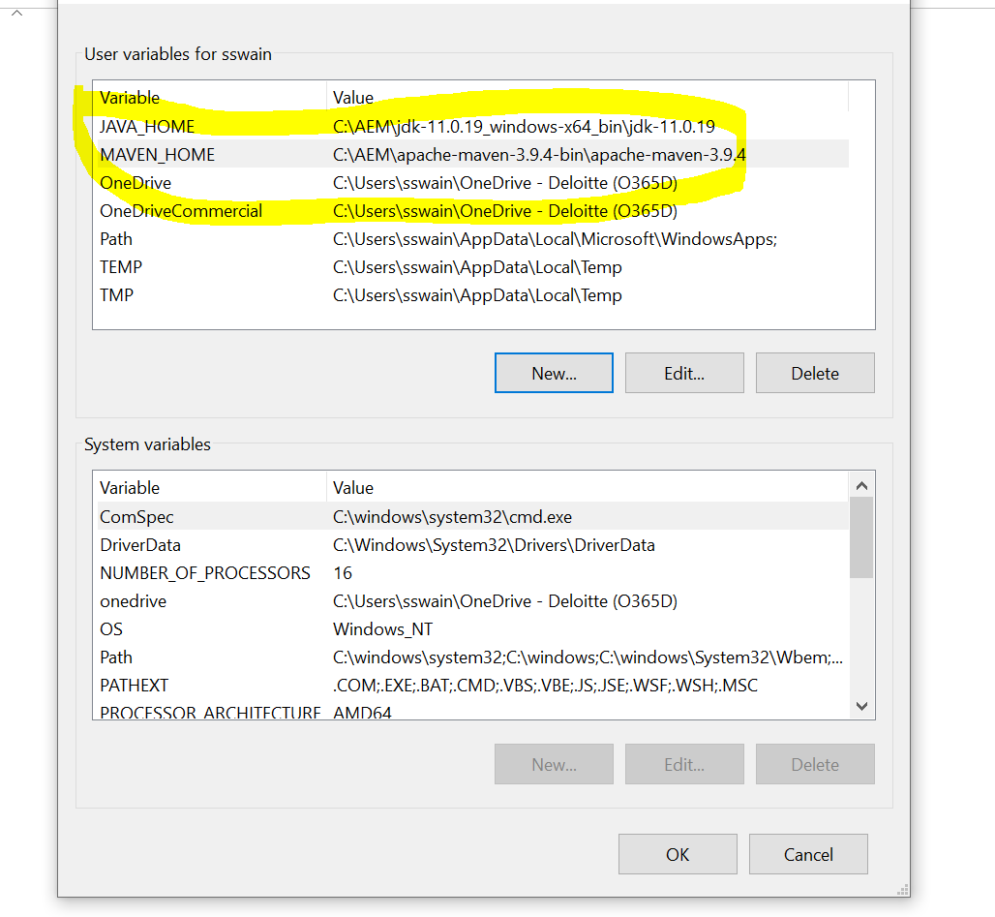

(We must edit "Path" as well from system variables and add paths till bin.)

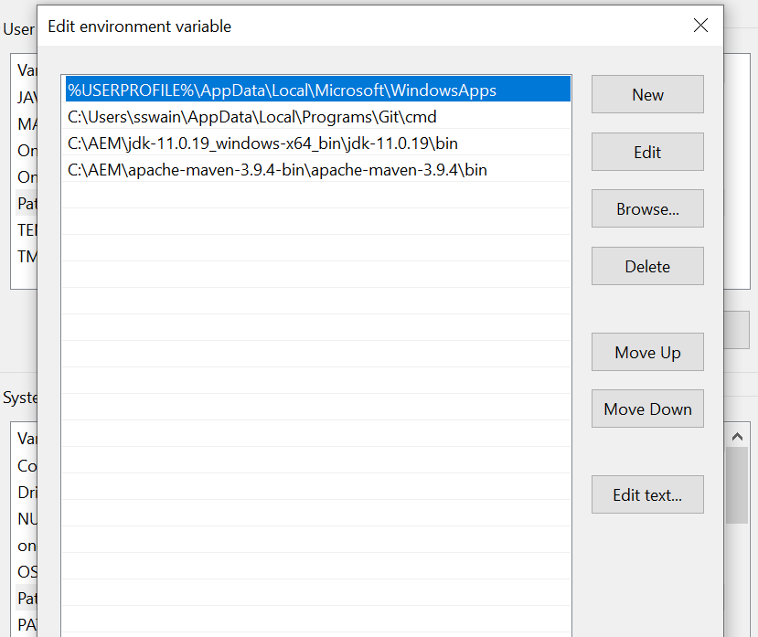

(Note : Execute “java -version” and “mvn -v” in command prompt). You should get following details on the screen.

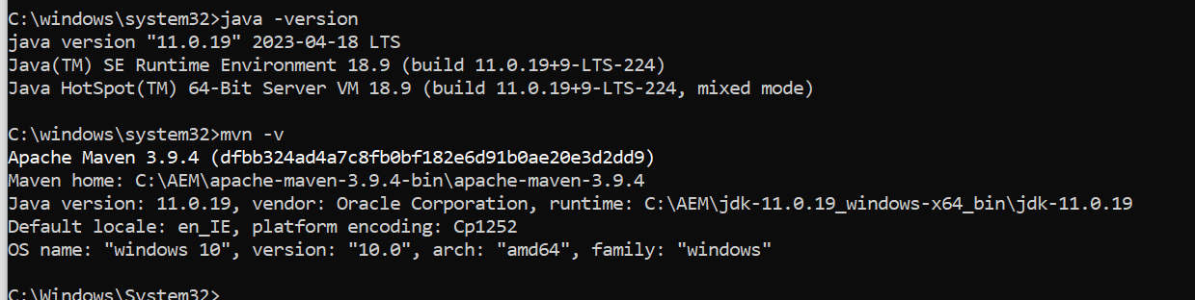

1. Once all the above steps completed , please copy the following jar and license file to a specific folder. In my case I copied those under “C:\AEM\author”.

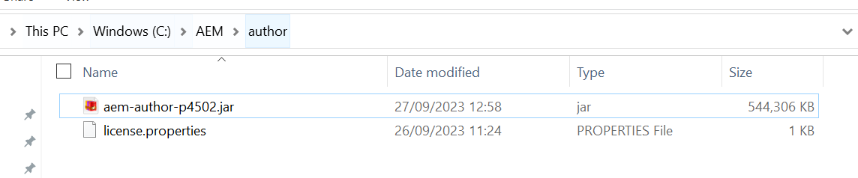

1. Now AEM is ready to use. Run the below command in command Prompt.

(Note : If crx-quick.. folder is already created then delete it).

**java -jar aem-author-p4502.jar**

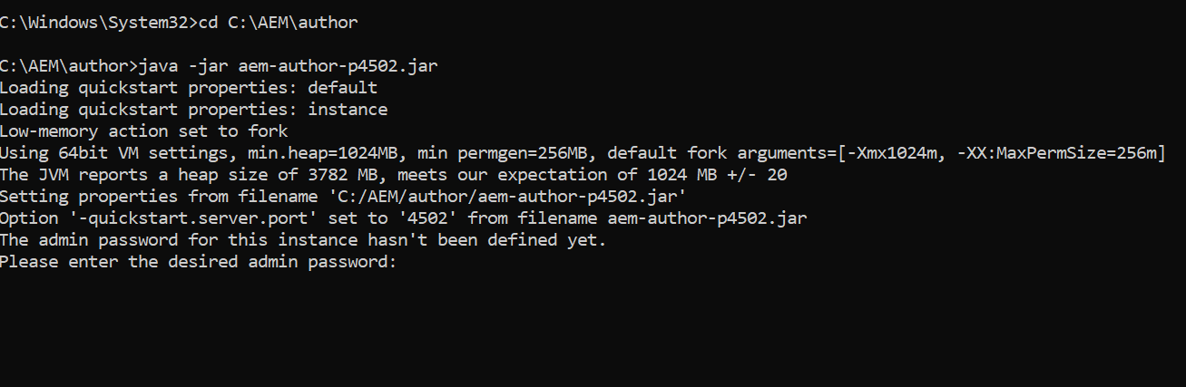

1. During the set up, it will prompt to enter a password. In my case I gave it as “a”. You need to remember the same as you need it for AEM log in.

(Note: This above step will take few minutes to complete so be patient 😊)

1. Once all the set up completed, following screen will be opened automatically.

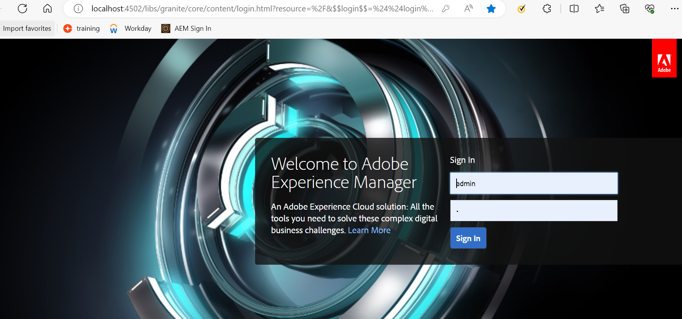

1. Please enter the password which you have entered in step 10. User name is “admin”.
2. We are ready to use our AEM as in this stage AEM should up now.

